AI-BASED FINANCIAL IDENTIFICATION BASED ON DEMOGRAPHY AND FINANCIAL FORECASTING
Conclusion, Future Scope and References
Product: FinSight AI
Department of Computer Science and Engineering, TKR College of Engineering and Technology (Autonomous)
Batch C9 (CSE-C) · Academic year [ACADEMIC YEAR]
Table 1: Project team
S.No. | Student name | Roll number
1 | MOHD AHMED | 23K91A05F7
2 | MANNE UPENDER | 23K91A05E6
3 | PADALA RAJESH | 23K91A05H7
4 | MADAGOUNI HARSHAVARDHAN GOUD | 23K91A05D5

Project guide: B SRIKANTH
Chapter and section numbers quoted in the text (for example Section 6.6 or Chapter 8) refer to the full project report, 17.Final Document. Figures and tables in this document are numbered from 1.

CONCLUSION AND KEY FINDINGS
FinSight AI shows that the explainable machine-learning framework of the base paper [1] can be moved from organisations to individuals and wrapped in a working application: twelve demographic and financial inputs become a profile, a risk band, a strength score, a live explanation and a forecast context in about 69 ms on a desktop CPU.

Objectives against outcomes
Table 2: The six project objectives and their status
No. | Objective | Status | Outcome
1 | Collect a dataset combining demographic attributes with financial and transactional parameters. | Met in part | UCI Adult / Census Income, 48,842 individual records with age, education, occupation, location (native country), and capital gains and losses. It has no transaction-level data, so the 'transactional parameters' part is not met.
2 | Preprocess the data, handle missing values and encode categorical demographic fields. | Met | '?' markers turned into missing values, median / 'Unknown' imputation and one-hot encoding inside each scikit-learn Pipeline, and 12 interpretable derived features.
3 | Train models to classify financial profile and estimate credit or distress risk. | Met in part | Four classifiers trained; XGBoost selected. The target is income above 50K, mapped to Emerging / Developing / Established profiles with Low / Moderate / High risk bands. It is not a credit-default or distress label.
4 | Build a forecasting component that projects future financial position. | Met in part | Holt-Winters 12-month forecast with a 95% band is built and served, but on a documented synthetic Household Financial Conditions Index; it does not forecast an individual's own finances.
5 | Add an explainability layer showing which factors drove each assessment. | Met | SHAP global importance, live per-assessment SHAP contributions in plain language, and a labelled non-causal what-if comparison.
6 | Evaluate using accuracy, precision, recall and ROC-AUC, and deploy through a web interface. | Met | Accuracy, precision, recall, F1 and ROC-AUC reported for all four models; the system is deployed as a Flask API with a React interface on ports 8409 and 5409.

Key findings
• XGBoost is the best of the four. On 9,769 held-out records it reaches accuracy 87.8%, precision 79.2%, recall 66.6%, F1 0.724 and ROC-AUC 0.932; its five-fold cross-validated AUC is 0.929 with a standard deviation of 0.001.
• Boosted trees beat the linear baseline, but not by a lot. Logistic Regression reaches AUC 0.914 and F1 0.676; Random Forest has AUC 0.910 (below the linear model) but a higher recall (63.7% against 61.1%) and F1 (0.685). The ordering by AUC is XGBoost, Gradient Boosting, Logistic Regression, Random Forest, the same family ordering as in the base paper except for the position of Random Forest.
• Recall is the weak point. At 0.5 the model finds 66.6% of the people with income above 50K. Moving the threshold to 0.35 gives recall 78.1%, precision 69.0% and the best F1 (0.733); the choice is a business decision, not a statistical one.
• Probabilities are well calibrated on this data. The mean prediction tracks the observed rate in nearly every one of ten bins (for example 0.984 predicted against 0.987 observed in the top bin) and the Brier score is 0.086; the largest gap is in the 0.4-0.5 bin (0.447 against 0.406).
• The profile bands carry information. In the test split 7.2% of the Emerging band, 44.0% of the Developing band and 85.2% of the Established band actually earn more than 50K.
• What drives the model. The five largest mean absolute SHAP values belong to marital status = Married-civ-spouse, Age, Years of education, Investment gains and hours worked per week. These are associations learned from 1994 census data, not causes.
• The forecast works as software, but its series is synthetic. The 12-month Holt-Winters forecast projects a +3.46% move of the index; against its own generator the back-test error is MAPE 1.00%, which says nothing about real economies.
• The system is fast and tested. A prediction takes a median of 68.9 ms; 9 automated tests and 35 of 35 smoke checks pass.
These findings are bounded by the limits described in the scope and limitations: old US data, an income target, a synthetic forecast series and no fairness audit.
The figures below summarise the measurements behind the conclusions: the first chart compares the four classifiers on the same 9,769 held-out records and the second shows how precision and recall of the selected model trade off as the decision threshold moves.
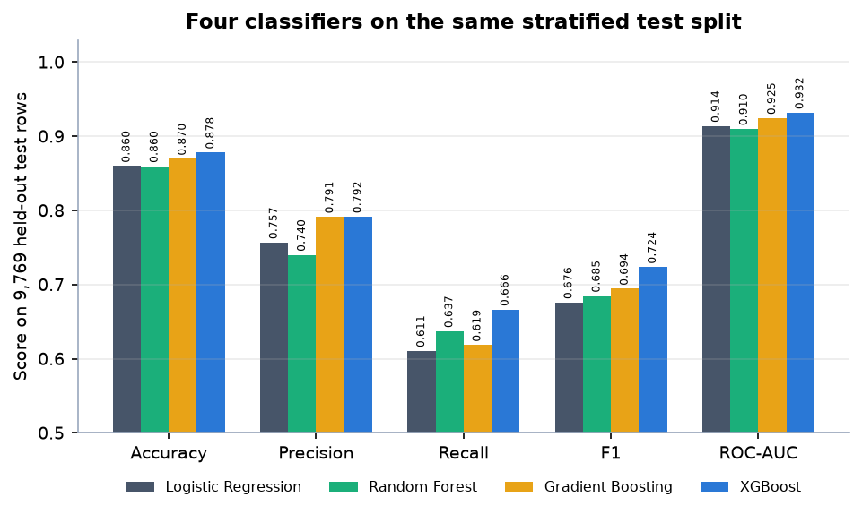
Figure 1: The four classifiers compared on the held-out test split
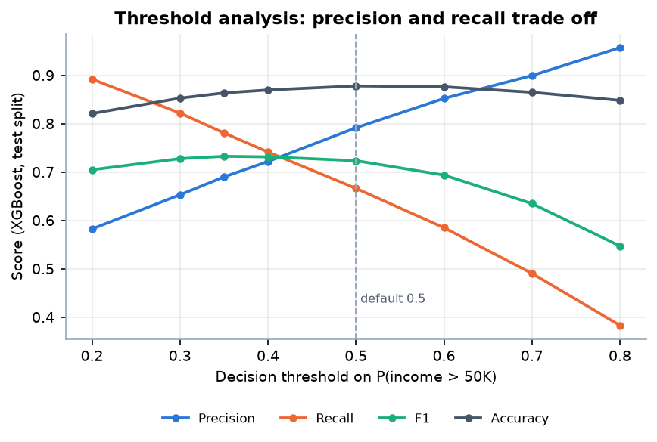
Figure 2: Threshold analysis of the selected XGBoost model

FUTURE SCOPE
The most valuable next steps follow directly from the limitations.
1. Real data. Replace the synthetic index with public macroeconomic series (inflation, unemployment, benchmark rates, GDP) as the abstract proposed, and retrain on a current, non-US household survey.
2. Credit and distress targets. Train on a labelled repayment or distress outcome and compare it with the income-based profile, with the base paper's entity-grouped and temporal validation.
3. Fairness work. Report error rates by sex, race and age group, test removing or masking sensitive inputs and apply a mitigation such as equalised odds post-processing.
4. Calibration and thresholds. Apply Platt or isotonic recalibration, add a validation set, search hyperparameters and test model differences for significance.
5. Personal forecasting. Let a user enter a short income and expense history and forecast it with a state-space or machine-learning model, with prediction intervals.
6. Production hardening. Real authentication, secret management, a database for optional history, containerised deployment of both services, and load and security testing.

REFERENCES
[1] Y. Kim and E. J. Sun, "An explainable machine learning framework for organizational financial distress detection: Evidence from Korean hospital panel data," IEEE Access, vol. 14, pp. 100337-100350, 2026, doi: 10.1109/ACCESS.2026.3709346.
[2] A. Abid, "Forecasting sovereign credit risk amidst a political crisis: A machine learning and deep learning approach," J. Risk Financial Manag., vol. 18, no. 6, Art. no. 300, Jun. 2025, doi: 10.3390/jrfm18060300.
[3] A. Maurino, "How data quality affects machine learning models for credit risk assessment," in Proc. Workshop AI Data Sci. Digit. Finance, held with ACM Int. Conf. AI Finance (ICAIF), Singapore, 2025.
[4] H. Zhang, J. Xu, J. He, and X. Fang, "Privacy-preserving credit risk prediction with alternative data," arXiv:2606.10333, Jun. 2026.
[5] E. I. Altman, "Financial ratios, discriminant analysis and the prediction of corporate bankruptcy," J. Finance, vol. 23, no. 4, pp. 589-609, Sep. 1968.
[6] J. A. Ohlson, "Financial ratios and the probabilistic prediction of bankruptcy," J. Accounting Res., vol. 18, no. 1, pp. 109-131, 1980.
[7] L. Breiman, "Random forests," Mach. Learn., vol. 45, no. 1, pp. 5-32, 2001.
[8] J. H. Friedman, "Greedy function approximation: A gradient boosting machine," Ann. Statist., vol. 29, no. 5, pp. 1189-1232, Oct. 2001.
[9] T. Chen and C. Guestrin, "XGBoost: A scalable tree boosting system," in Proc. 22nd ACM SIGKDD Int. Conf. Knowl. Discovery Data Mining, Aug. 2016, pp. 785-794.
[10] F. Barboza, H. Kimura, and E. Altman, "Machine learning models and bankruptcy prediction," Expert Syst. Appl., vol. 83, pp. 405-417, Oct. 2017.
[11] M. Zieba, S. K. Tomczak, and J. M. Tomczak, "Ensemble boosted trees with synthetic features generation in application to bankruptcy prediction," Expert Syst. Appl., vol. 58, pp. 93-101, Oct. 2016.
[12] M. Moscatelli, F. Parlapiano, S. Narizzano, and G. Viggiano, "Corporate default forecasting with machine learning," Expert Syst. Appl., vol. 161, Art. no. 113567, Dec. 2020.
[13] F. Mai, S. Tian, C. Lee, and L. Ma, "Deep learning models for bankruptcy prediction using textual disclosures," Eur. J. Oper. Res., vol. 272, no. 2, pp. 743-758, 2019.
[14] S. M. Lundberg and S.-I. Lee, "A unified approach to interpreting model predictions," in Proc. Adv. Neural Inf. Process. Syst., vol. 30, 2017, pp. 4765-4774.
[15] S. M. Lundberg et al., "From local explanations to global understanding with explainable AI for trees," Nature Mach. Intell., vol. 2, no. 1, pp. 56-67, Jan. 2020.
[16] M. T. Ribeiro, S. Singh, and C. Guestrin, "'Why should I trust you?': Explaining the predictions of any classifier," in Proc. 22nd ACM SIGKDD Int. Conf. Knowl. Discovery Data Mining, 2016, pp. 1135-1144.
[17] N. Bussmann, P. Giudici, D. Marinelli, and J. Papenbrock, "Explainable machine learning in credit risk management," Comput. Econ., vol. 57, no. 1, pp. 203-216, Jan. 2021.
[18] A. Gramegna and P. Giudici, "SHAP and LIME: An evaluation of discriminative power in credit risk," Frontiers Artif. Intell., vol. 4, Art. no. 752558, Sep. 2021.
[19] J. Cerneviciene and A. Kabasinskas, "Explainable artificial intelligence (XAI) in finance: A systematic literature review," Artif. Intell. Rev., vol. 57, no. 8, pp. 1-80, Jul. 2024.
[20] A. Barredo Arrieta et al., "Explainable artificial intelligence (XAI): Concepts, taxonomies, opportunities and challenges toward responsible AI," Inf. Fusion, vol. 58, pp. 82-115, Jun. 2020.
[21] F. Doshi-Velez and B. Kim, "Towards a rigorous science of interpretable machine learning," arXiv:1702.08608, 2017.
[22] C. Molnar, G. Casalicchio, and B. Bischl, "Interpretable machine learning - A brief history, state-of-the-art and challenges," in Proc. ECML PKDD Workshops, 2020, pp. 417-431.
[23] L. Grinsztajn, E. Oyallon, and G. Varoquaux, "Why do tree-based models still outperform deep learning on typical tabular data?" in Proc. Adv. Neural Inf. Process. Syst., 2022, pp. 507-520.
[24] F. Pedregosa et al., "Scikit-learn: Machine learning in Python," J. Mach. Learn. Res., vol. 12, pp. 2825-2830, 2011.
[25] T. Hastie, R. Tibshirani, and J. Friedman, The Elements of Statistical Learning: Data Mining, Inference, and Prediction, 2nd ed. New York, NY, USA: Springer, 2009.
[26] M. Stone, "Cross-validatory choice and assessment of statistical predictions," J. Roy. Stat. Soc., Ser. B, vol. 36, no. 2, pp. 111-133, 1974.
[27] D. W. Hosmer, S. Lemeshow, and R. X. Sturdivant, Applied Logistic Regression, 3rd ed. Hoboken, NJ, USA: Wiley, 2013.
[28] T. Fawcett, "An introduction to ROC analysis," Pattern Recognit. Lett., vol. 27, no. 8, pp. 861-874, Jun. 2006.
[29] J. A. Hanley and B. J. McNeil, "The meaning and use of the area under a receiver operating characteristic (ROC) curve," Radiology, vol. 143, no. 1, pp. 29-36, 1982.
[30] E. R. DeLong, D. M. DeLong, and D. L. Clarke-Pearson, "Comparing the areas under two or more correlated receiver operating characteristic curves: A nonparametric approach," Biometrics, vol. 44, no. 3, pp. 837-845, Sep. 1988.
[31] R. Kohavi, "Scaling up the accuracy of Naive-Bayes classifiers: A decision-tree hybrid," in Proc. 2nd Int. Conf. Knowl. Discovery Data Mining (KDD), 1996, pp. 202-207.
[32] UCI Machine Learning Repository, "Adult (Census Income) data set." [Online]. Available: https://archive.ics.uci.edu/dataset/20/census+income
[33] P. R. Winters, "Forecasting sales by exponentially weighted moving averages," Manage. Sci., vol. 6, no. 3, pp. 324-342, Apr. 1960.
[34] C. C. Holt, "Forecasting seasonals and trends by exponentially weighted moving averages," Int. J. Forecasting, vol. 20, no. 1, pp. 5-10, 2004.
[35] R. J. Hyndman and A. B. Koehler, "Another look at measures of forecast accuracy," Int. J. Forecasting, vol. 22, no. 4, pp. 679-688, 2006.
[36] R. J. Hyndman and G. Athanasopoulos, Forecasting: Principles and Practice, 3rd ed. Melbourne, Australia: OTexts, 2021.
[37] C. Guo, G. Pleiss, Y. Sun, and K. Q. Weinberger, "On calibration of modern neural networks," in Proc. Int. Conf. Mach. Learn. (ICML), 2017, pp. 1321-1330.
[38] A. Niculescu-Mizil and R. Caruana, "Predicting good probabilities with supervised learning," in Proc. 22nd Int. Conf. Mach. Learn. (ICML), 2005, pp. 625-632.
[39] M. Hardt, E. Price, and N. Srebro, "Equality of opportunity in supervised learning," in Proc. Adv. Neural Inf. Process. Syst., vol. 29, 2016, pp. 3315-3323.
[40] N. Mehrabi, F. Morstatter, N. Saxena, K. Lerman, and A. Galstyan, "A survey on bias and fairness in machine learning," ACM Comput. Surv., vol. 54, no. 6, Art. no. 115, 2021.
[41] S. Seabold and J. Perktold, "Statsmodels: Econometric and statistical modeling with Python," in Proc. 9th Python Sci. Conf. (SciPy), 2010, pp. 92-96.
[42] Pallets Projects, "Flask: Web development, one drop at a time." [Online]. Available: https://flask.palletsprojects.com
[43] Meta Platforms, Inc., "React: The library for web and native user interfaces." [Online]. Available: https://react.dev
[44] Vite contributors, "Vite: Next generation frontend tooling." [Online]. Available: https://vite.dev
[45] "Credit and financial cycle synchronization: Impact on sovereign credit risk," 2025 (entry recorded in the batch literature survey; not independently verified).
[46] "Financial and credit risk research," 2024 (entry recorded in the batch literature survey; not independently verified).
[47] "Design of a multimodal credit risk forecasting system for financial text analysis," in Proc. 2nd Int. Symp. Integr. Circuit Design Integr. Syst., 2025 (entry recorded in the batch literature survey; not independently verified).

